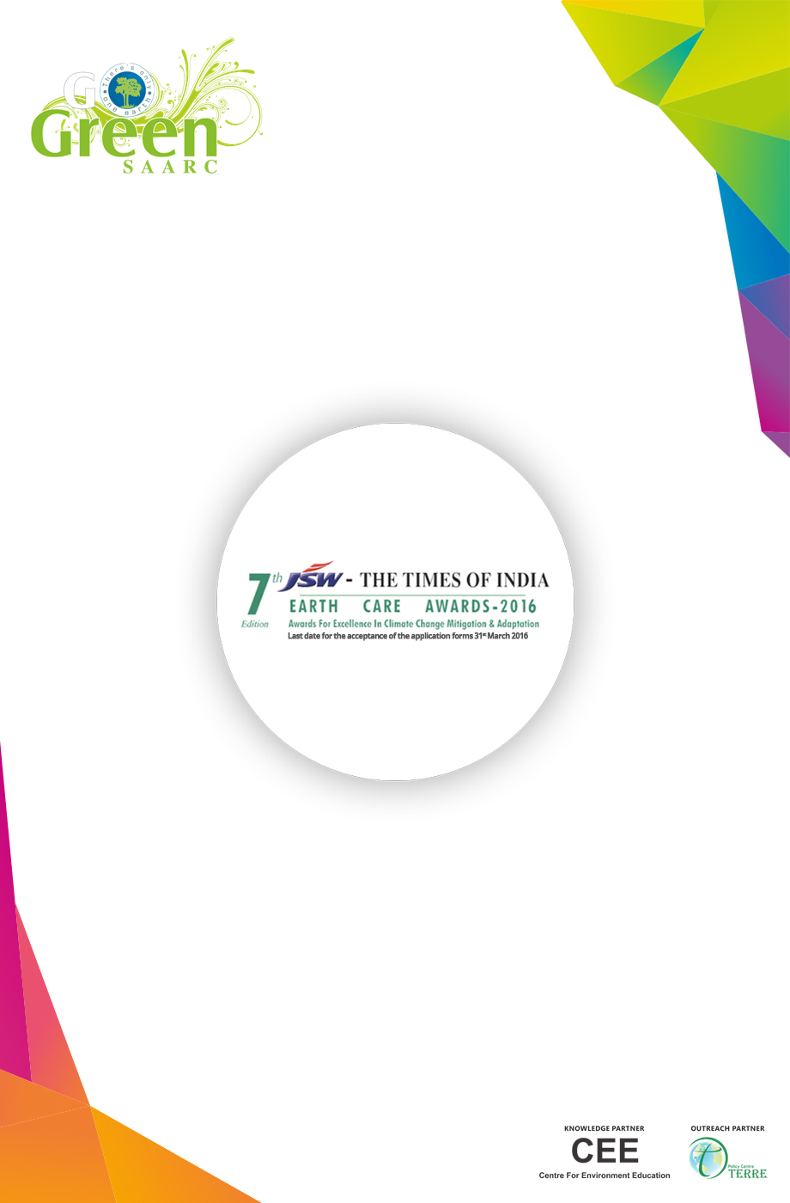

APPLICATION FORM
Category: GHG Mitigation in Large Scale Enterprises
PART - A: GENERAL INFORMATION

Name of Industry
Sector
Type of Organization (Tick any one)
Private Sector Public sector Unit (PSU) Other (Please Specify)
Corporate Office Unit Location Contact Person
Address

Phone Email

PART B: TECHNICAL INFORMATION
Section I - Policy
1. Provide
a. Energy Policy
b. Climate Change Policy
Please elaborate on policy and targets
2. Elaborate on means of implementation

Section II - Project Information
3. Describe the project with specific reference to product and processes
4. Provide detail description on process and areas having energy as key resource input
5. Elaborate on the significance of project in the entire process chain and its impact in overall energy use reduction.

Section III - Energy Audit and implementation - Information on steps towards reductions in GHG emissions
6. Provide details on energy audit, process audit and implementation strategy for the last three years.
Provide copy of energy audit report and implementation status.
7. Details of initiatives with quantitative information for
a. Energy efficiency enhancement
b. Process improvements
c. Emission reduction
d. Supply chain management
Provide details for last three financial years
www.facebook.com/earth.care.awards www.earthcareawards.com

8. Energy and water consumption pattern during last three years
a. Per unit production
b. Total consumption
c. Savings
9. Provide comparisons on energy and water consumption per unit of production against the national and international benchmark over last three year
10. Please provide status of your unit, with respect to Perform, Achieve and Trade scheme of Bureau of Energy Efficiency and target specified. (Applicable if the sector is covered under PAT)
11. Elaborate on methodologies adopted by your industry on internal and external monitoring and verification of the performance.
12. Elaborate on use of renewable/alternative energy for production. Provide details for last three years. In case not, provide reasons and barriers - technological, financial, policy etc.
13. List financial gains achieved vis-à-vis investment and nature of financial/technical support received to undertake the activities. (Government or any other mechanism)

CDM
14. Please elaborate on the status of CDM projects registered by unit/firm. Provide details on projects approved and under process including project design document (PDD)
Resource Efficiency and Carbon Proofing
15. Elaborate on the key material aspects with natural resource constraints and stresses in the area of operation and their mitigation measures.
16. Elaborate on climate change risk assessment with respect to raw material and supply chain. Provide details with respect to carbon proofing initiatives.
Section III - Environment Management
17. Regulatory framework or compliance requirement applicable to the unit including HSE, EMS, ISO 18001 etc. Pl elaborate
18. Please describe the waste streams from your firm/organizations and efforts undertaken to reduce/control them. (Provide supporting documents including details on air, water and hazardous waste discharge parameters)
19. What is the compliance status of the firm over the last three years? Please attach copies of consent to operate (Water Act, Air Act & Hazardous Waste (Management & Handling) Rules and its amendments) and other relevant documents.
20. Provide disclosure on any notices or closure or indictment for non-conformance to pollution norms

Section IV - Social Commitment
21. Organization approach to stakeholder engagement including process to address community/stakeholder concerns. Provide details on planning process and identification of beneficiary and fund allocation
22. Attach CSR policy statement with a brief listing of CSR activities.
Section V - Association and awards
23. Are you associated with Carbon Disclosure project or any such disclosure activities, if yes provide details. Attach reports for last three years, if applicable
24. Has your organization won any awards related to Environment/Energy in past? If yes, please provide details. (Attach relevant citations/documents)

www.facebook.com/earth.care.awards www.earthcareawards.com

