APPLICATION FORM
Category: Community based mitigation and adaptation in Water Resources, Agriculture, Forestry and Other Land Use

PART - A: GENERAL INFORMATION
Name and Address of Organization:
Type of organization (Tick any one)
Government NGO
Local Community Groups- CBOs/JFM/WUA/ Others

Name: ____________________ Address of Project site: __________________________________
______________________________________________ ____________________________________________________
Head Office: ____________________________ Name and designation of contact person: ___________________
______________________________________________ _____________________________________________________
Phone: ________________________________________ Phone: ___________________ Mobile: ____________________
E-mail: ________________________________________ E-mail: ______________________________________________

Section A: About the Organisation
1. Year of registration with details (Attach latest annual report and with financial details)
2. Organizational profile (150 words) with organogram
Section B: Climate Change and your organisation
1. Elaborate on climate change challenge with your organization objective and interlinkages with thrust areas?(200 words)
2. Describe relevance of your work/ interventions with reference to climate change adaptation.(200 words)
3.` How long the organization working in area of climate change and major activities under climate change
PART – B: PROJECT INFORMATION
Section I: About the project
(Projects related to Water Resources, Agriculture, Forestry and Other Land Use)
Only completed projects established only after April 2005 will be considered.
- Project and its objectives¹
Provide project summary describing background and key highlights of the project
2 Status of the project as on date (Tick any one and give details):
Start and end date
Start and end date of the project (Note that project completed before 2015 will only be considered)

3. Thematic area of intervention
Thematic/Focal Area (you can select thematic and sub thematic area as per project objective)
Land use, land use change Livelihood security
Water resources and watershed development Eco tourism
Sustainable forest management Disasters risk reduction
Sustainable agriculture Health
Bio diversity conservation Eco restoration
4. Elaborate on project scale – Specify the geographical coverage and the direct beneficiaries.
5. Please add district/area map indicating project/intervention sites. In case a proper map is not available, you may draw and depict locations for clarity
Section II: The climate context - Vulnerability and Adaptation
6. Elaborate on the climate vulnerability of the project area (200 words)
7. What was the process of identification of vulnerabilities at project sites/villages; how these has been assessed and risks identified (200 words)
8. Please elaborate on the Climate Change adaptation measures; how it’s devised and established (200 words)
9. Please give a brief about the initial concept of the project. Any midcourse changes applied for incorporating climate change as project objective can also be highlighted.

Section III: Project activities
10. Describe in detail the process of implementation³
a. Physical activities undertaken,
Please describe what is being done to achieve the results and accomplish the project's objectives
Detail out the activities related to the enhancing the risk resilience and adaptation measures with outcomes in quantitative and qualitative terms. The rationale/purpose should reflect the linkage of measure with the reduction in specific vulnerability identified
Activities / interventions | Purpose/Rationale | Outcome

b. Physical activities corresponding leading to mitigation actions - CO₂ emission reduction
Guidance on Mitigation actions
Several measures lead to reduction in greenhouse gas emissions like CO₂, CH₄, N₂O etc. These can be efforts leading to reduced use of fertilizers, plantation, biogas, alternative energy and use of locally available material for watershed activity reducing use of cement and other energy intensive raw materials.
A unit of biogas uses methane and avoids CO₂ emissions from use of fossil fuels. A tree planted sequesters (absorbs) CO₂ and stores it in form of biomass. Increase in water table in the watershed region, increases soil organic carbon, increases productivity and reduces dependence of chemical fertilizers. Increase in water table also reduces dependence on pumps or reduces its frequency of operation and thus avoids fuel use.
Activities | Reduction in CO₂ or CO₂ e

11. Describe in detail the indicators and baseline condition of the project before implementation and after implementation (please add relevant verifiable indicators and the baseline conditions according to your interventions) for example.
a. No. of wells; reduction distance traveled to source drinking water; water availability under adverse conditions; quality of water; fodder availability; firewood; cropping pattern; income per hectare; migration; flood and drought prevention; income per family
b. Non Timber Forest Produce (NTFP); biodiversity; forest Practices; forest fires; flood area; soil erosion, improvements in landscape physical features; soil characteristics (nutrients); yield characteristics in the case of land resources.

This should be in relation with the baseline and vulnerability identified; describe the situation before and after the project with supporting data.
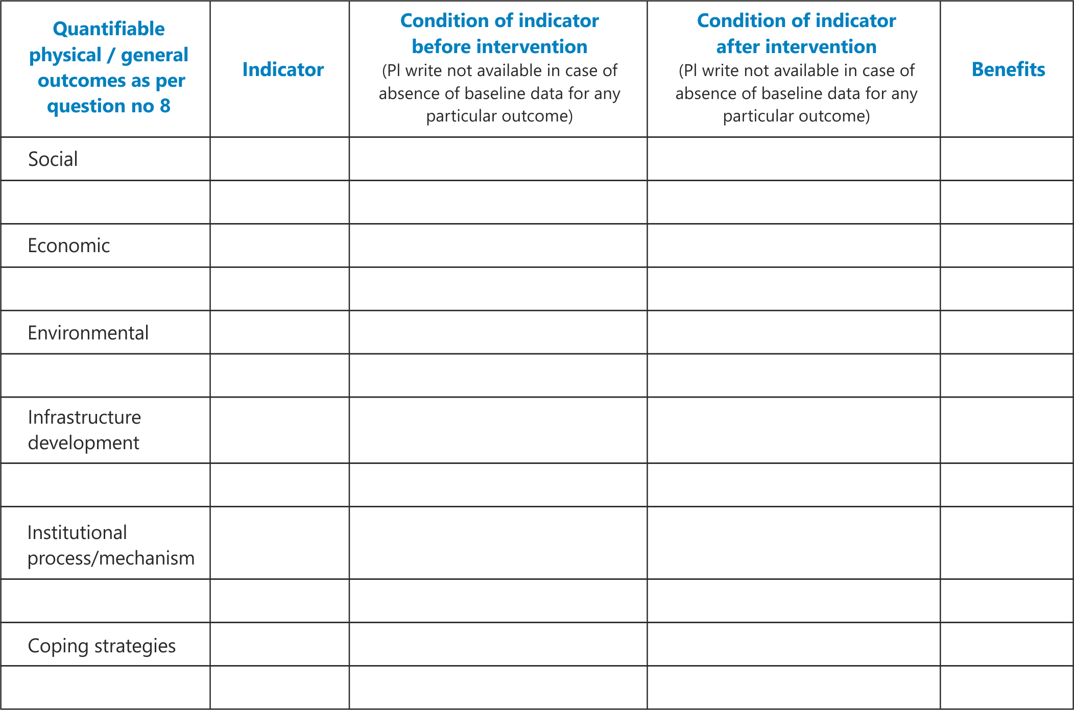

12. Elaborate on monitoring framework; and results measurement process
13. Has your project/activity undergone any evaluation/monitoring by an independent agency? If yes, please provide details.
Provide copy of reports submitted to donor agency or prepared by external agency
14. Do you foresee potential of replication of your activity, if yes; suggest ways to achieve it. Describe the model of implementation and its replicability in the region.
15. State any specific limitations which interfere with achieving the project objectives.

Section IV: Knowledge, Training and capacity building
16. Elaborate on the traditional knowledge with respect to environment and sustainable practices, its adoption, documentation and dissemination
17. How climate change training and capacity building has been integrated with institution building and project activities
18. Elaborate on climate change communication and training with specific focus on significance of activity, new knowledge created and disseminated
Section V: Sustainability
19. Please let us know the sustainability of the project (Please elaborate on institutional, economic and environmental sustainability and the withdrawal strategy for the project)
20. Has this project influenced any government policy/scheme? Explain what the government policy is, how it has been affected.

21. Nature of financial support received for project (All figures in INR/USD)
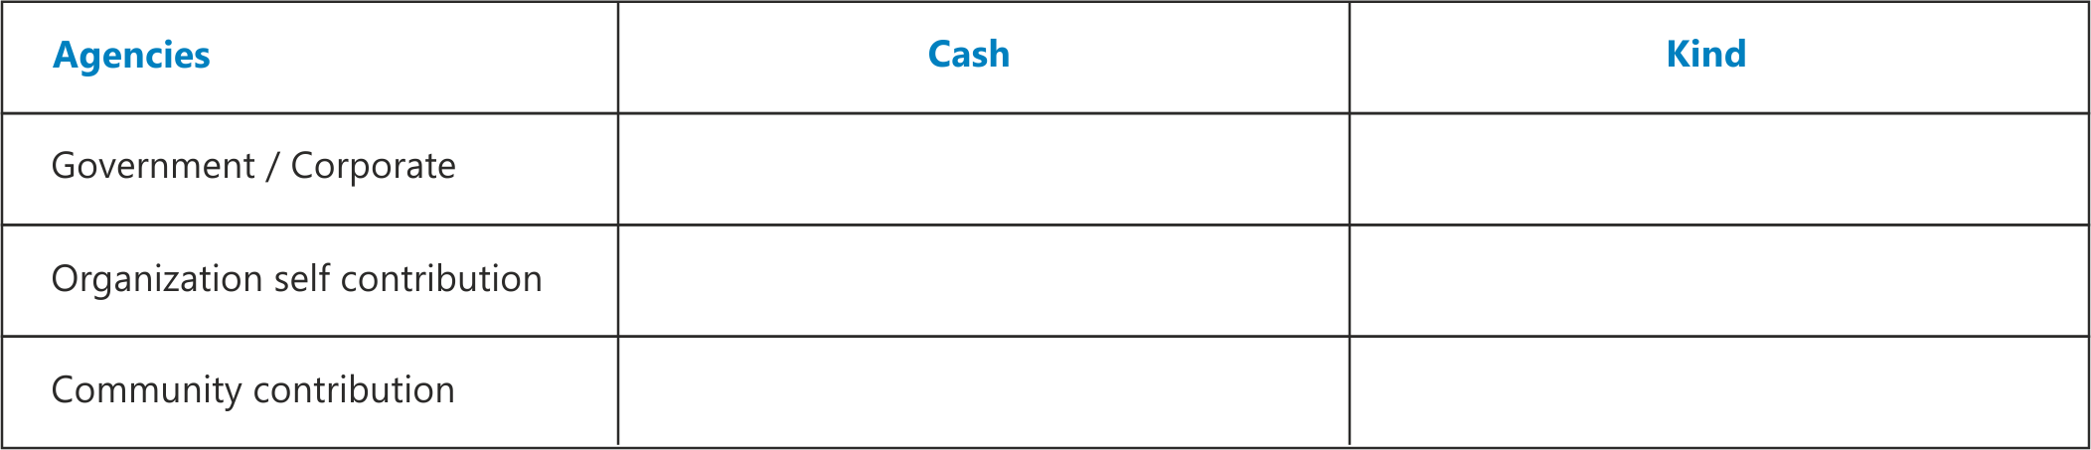
22. Please specify if any partners were part of this project. Also specify their roles and responsibilities
23. Any other relevant information/ report/ experience you would like to share with us
24. Any awards secured in the recent past on natural resource management. If yes provide details. You can also attach letters of appreciation/ testimonials (if any)
25. Are any public institutions created? If yes please give details

